卡通人物

The two plates that attached to the arm are made of non-metal material, from the texture of its outside surface, can guess speculate the possibility of carbon fiber or similar material.

Two nylon straps that connect to the two plates are used to fix the exoskeleton to the user’s arm, one of them is located at the upper arm, where the plate will cover the triceps and outer side of the biceps. The other pair is located at the forearm where the plate is beneath and the outer side of the forearm.

The frame of the whole structure is made of metal.

The structure at the hand has the functionality of helping bend the second and third fingers so the user can hold or grasp an item.

Another plate is beneath the hand and can be attached to the thumb with strap, there is a metal V-shape structure that helps fix the position of the thumb

The buttery, microprocessor, motor, gearbox are located at the joint of the structure. The motor can be seen is at the back of the triceps since it is long. And the connection of the upper arm and forearm is under the gear with a bigger radius.

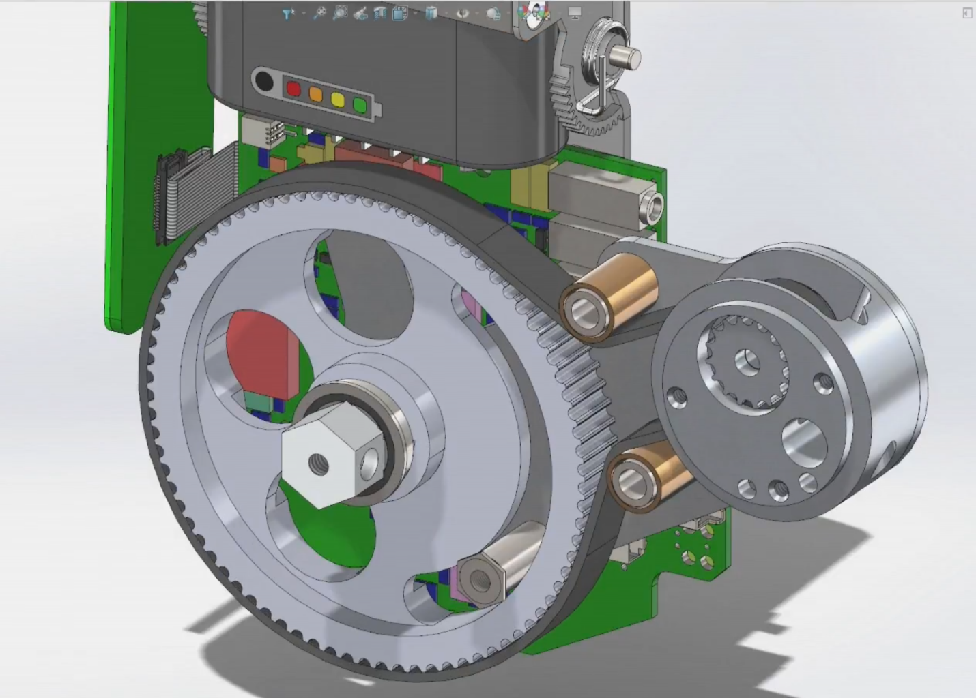

In the above figure is the back side of the gearbox module, the gear and the pinion is connected by strap and there are two plain bearings to restrict the space occupied. The nut that is at the shaft end of the gear is connected to the forearm.

It can be seen that there is a special structure on the gear that can limit the rotation angle of the gear, which is also the forearm structure for safety purpose.

The mechanism of bending fingers are not shown in the video and since it does not require much force, the inner structure may not be complicated.

文本

A metal structure at the wrist that will help fix the whole forearm structure as well as the hand structure. However, with this whole structure the user will not be able to rotate his wrist.

The connection of the wrist structure and the hand plate is adjustable, but the connecting bar and the plate are fixed using bolts which may not be comfortable.

According to the video, the product using millivolt microphone as input for the user to control the movement of his arm.

地上穿着球鞋的一双脚和枪

